**RISK PREDICTION IN CORPORATE FINANCIAL MANAGEMENT USING IBM AUTO AI SERVICE**

**Mini Project Report**

Submitted By **(BATCH NO: CSE_B_01)**

**KOPPULA SRIJA - 18UK1A0583**

**VANKAR AMISHA - 18UK1A05C2**

**ADUPA SOWMYA - 18UK1A05A9**

**KONDETI MUKESH - 18UK1A05E8**

**INDEX**

**TITTLE PAGE NO**

**CHAPTER 1: INTRODUCTION 4**

* 1. OVERVIEW
  2. PURPOSE

**CHAPTER 2: LITERATURE SURVEY 5**

**2.1** EXSISTING PROBLEM

**2.2** PROPOSED SOLUTION

**CHAPTER 3: THEORETICAL ANALYSIS 6**

**3.1** BLOCK DIAGRAM

**3.2** SOFTWARE SERVICE REQUIRED

**CHAPTER 4: PROJECT FLOWS 7**

**CHAPTER 5: DATA 8 - 9**

**CHAPTER 6: RESULTS 10**

**CHAPTER 7: APPLICATIONS 11**

**CHAPTER 8: CONCLUSIONS 11**

**CHAPTER 9: FUTURE SCOPE 11**

**CHAPTER 10: BIBILOGRAPHY 11**

**ABSTRACT**

A RISK PREDICTION is any measure that is used to predict a person’s risk of an event. Risk Prediction models have become an important part of Decision Making in quick and simple way. Nowadays there are many risks related to bank loans, especially for the banks so as to reduce their capital loss. The analysis of risks and assessment of default becomes crucial thereafter. Banks hold huge volumes of customer behavior related data from which they are unable to arrive at a judgement if an applicant can be defaulter or not.

The use of AI in financial risk prediction is still in its nascence, but the combination of an exponential increase in the amount of available data and improving ML algorithms to digest these data has the potential to greatly impact the corporate field especially Banks. The use of ML in financial risk management can be illustrated through two interesting applications that are developing rapidly: Probability of Default, Early Warning Signals.

This project discusses building a system for creating predictions that can be used in different scenarios. It focuses on predicting fraudulent transactions, which can reduce monetary loss and risk mitigation by building a web application. Using IBM Auto AI, we automate all of the tasks involved in building predictive models for different requirements from the dataset and predict the results.

**1. INTRODUCTION**

**1.1** OVERVIEW

Risk assessment is a crucial issue faced by Banks nowadays which helps them to evaluate if a loan applicant can be a defaulter at a later stage so that they can go ahead and grant the loan or not. This helps the banks to minimize the possible losses and can increase the volume of credits. The result of this credit risk assessment will be the prediction of Probability of Default (PD) of an applicant. Hence, it becomes important to build a model that will consider the various aspects of the applicant and produces an assessment of the Probability of Default of the applicant.

Using IBM Auto AI, the data set is analysed automatically through a series of respective algorithms mainly XGB Classifier (eXtreme Gradient Boosting) and LGBM Classifier (Light Gradient Boosting Machine) by constructing various pipelines. The algorithm of pipeline with highest accuracy is used for prediction i.e., XGB Classifier of pipeline 3 with accuracy 0.744 is used. Hence it is analysed by creating and deploying flask – based Web Application and integrate Auto AI model to it. According to the user inputs the results(prediction) are showcased on UI.

**1.2** PURPOSE

* Understand the historical data from dataset of a person’s details, Analyse and predicts whether the person is assessed for the credit (or) not
* Uses Auto AI Experiment
* Create a Web based UI to showcase Predictions

**2. LITERATURE SURVEY**

**2.1** EXSISTING PROBLEM

Banks hold huge volumes of customer behavior related data from which they are unable to arrive at a judgement if an applicant can be defaulter or not. Hence most of the financial organizations are interested and keen in making profits.

Previously, it is used to be done by manual processes using balance sheets and spread sheets. Accountants and Financial Advisors of organizations used to study and analyze old statistics, reports and by certain mathematical calculations and through some complex algorithms they try to find out the predictions according to person’s details. This type of manual approach could not able to provide desired exact accuracy and it is a quiet leanly process.

**2.2** PROPOSED SOLUTION

To overcome the drawbacks of manual decision making on assessment of credit, we have proposed Auto AI based Predictions. The predictions are based on efficient Machine Learning algorithm XGB Classifier. This system can able to provide more than 75% accuracy in the predictions of assessment of credit. Hence the model reduces fraudulent transactions which can reduce monetary loss and risk mitigation by building a Web Application.

**3. THEORETICAL ANALYSIS**

**3.1** BLOCK DIAGRAM

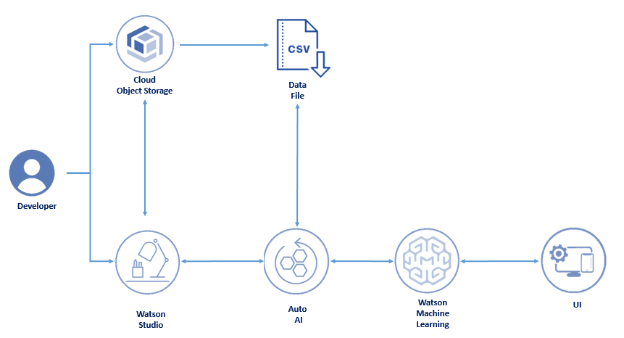

**3.2** SOFTWARE SERVICES REQUIRED

* IBM Watson Studio
* IBM Watson Machine Learning
* IBM Cloud Object Storage
* IBM Auto AI
* IBM Node-Red

**4. PROJECT FLOWS**

To accomplish this, we have to complete all the activities and tasks listed below

CREATE IBM SERVICE

* Create Watson Studio Service

BUILDING MACHINE LEARNING MODEL

* Collect the dataset
* Create Watson Studio Project
* Add Auto AI Experiment
* Run Auto AI Experiment
* Save the Model
* Deploy the Model

APPLICATION BUILDING

* Create Node-Red service from the cloud foundry of IBM Cloud and deploy the app
* Create a UI
* Set Global Variables to the UI
* Get the access token with the help of http request node
* Send the input values to scoring endpoint in Jason format along with the access token using http request node
* Get the Prediction
* Parse the Output
* Showcase the Output on the UI

**5. DATA**

Auto AI depends heavily on data, without data Auto AI can’t predict. Data is the crucial aspect and Auto AI trains the data by itself. It is the actual dataset used to train the model for performing various actions.

Dataset was imported from Kaggle

Our “german_credit_dataset” contains 1000 rows and 10 columns

* Age
* Sex
* Job
* Housing
* Saving account
* Checking account
* Duration
* Purpose
* Risk (Prediction)

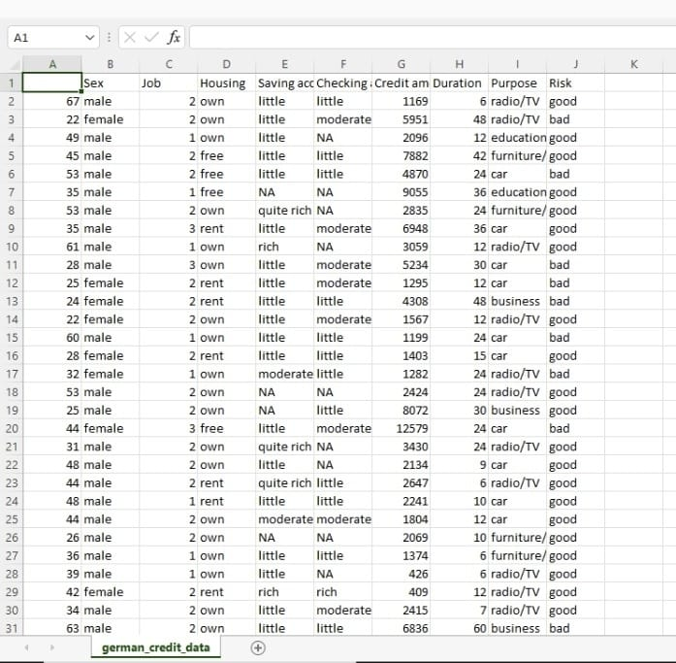

**6. RESULTS**

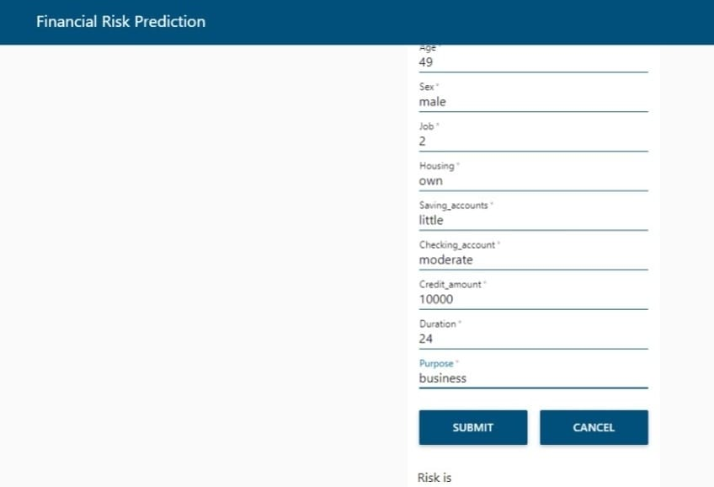

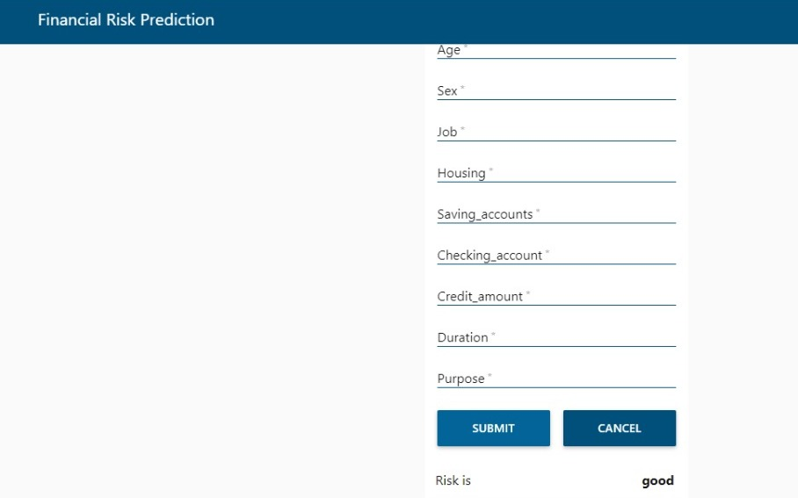

**7. APPLICATIONS**

Risk Prediction in Corporate Financial Management plays a crucial role. Not everything can be predicted reliably, if the factors that relate to what is being predicted are known and well understood. There should be significant amount of data that should be used for reliable predictions. If this is not the case or if the actual outcome is affected by predictions, the reliability of the risk predicted can be significantly lower.

Hence it reduces fraudulent transactions which can reduce monetary loss and risk mitigation of financial organisations.

**8. CONCLUSION**

* In this project, we have done the prediction on Credit Assessment after entering the person’s necessary details
* Prediction is done using Auto AI by XGB Classifier

**9. FUTURE SCOPE**

Risk prediction is an essential task for the Financial Corporate Management. Being able to estimate the Credit Assessment will allow the Organisations to make huge profits without any fraudulent transactions.

**10. BIBLIOGRAPHY**

* https://www.geeksforgeeks.org/
* https://www.w3schools.com/
* https://stackoverflow.com/
* https://www.lucidchart.com/pages/
* <https://smartinternz.com/Student/guided_project_info/>